Here in Brazil, we need only two Test Request:
- Exportation products
- Food and Feed

1-Test Request – Form for Exportation products
- Customer – ok – the same that we have now.
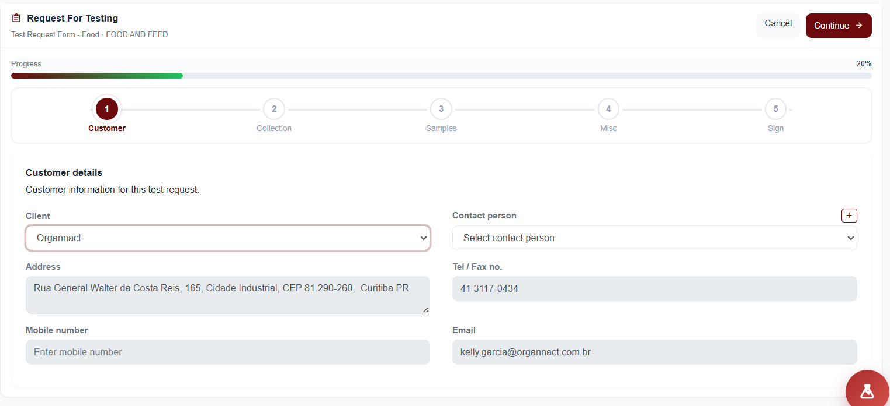

- Collection - we don´t need – we can skip

- Sample- Below
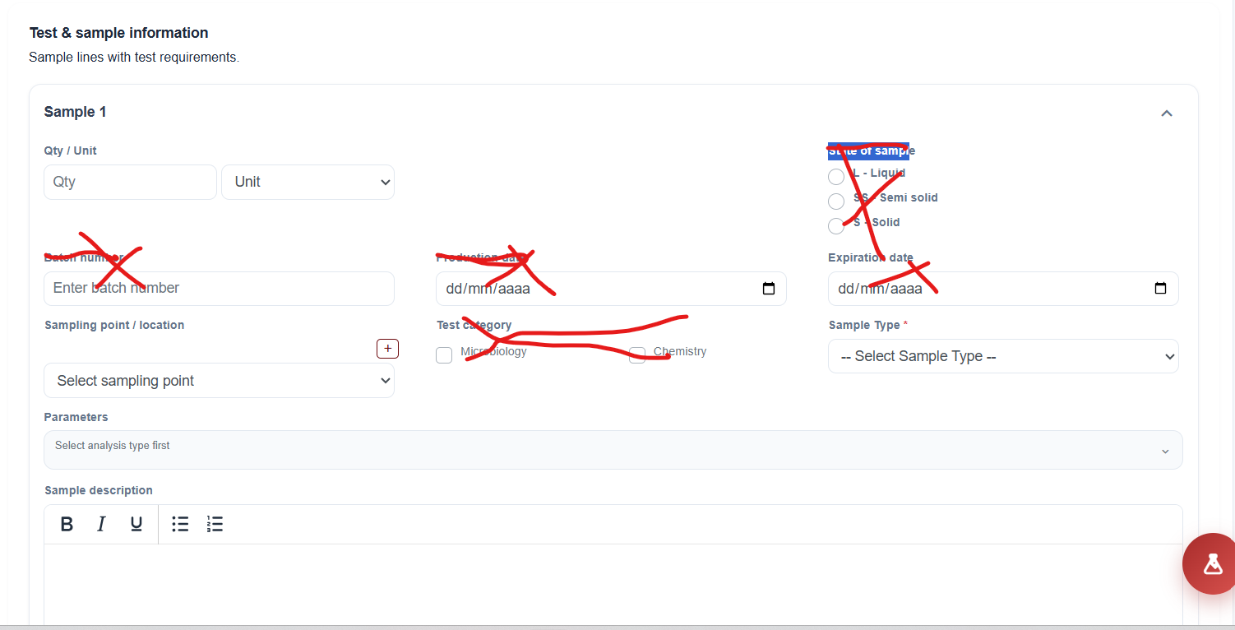
Fields should be deleted: Batch number, Production date, Expiration date, State of sample, Test category

One new field for samples (this field the customers are free for writing the sample). For example: Maize or Corn or Yellow Corn in Bulk. This is information that goes to Test Report.

- Misc – ok, the same that we have now.
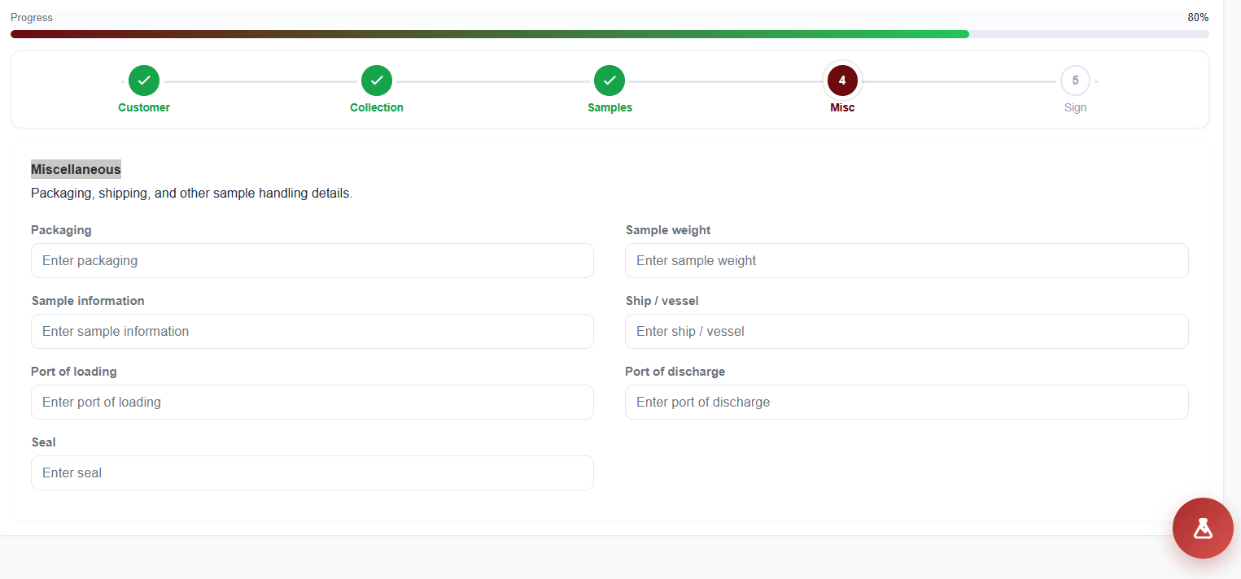
- Sign -ok, the same that we have now.
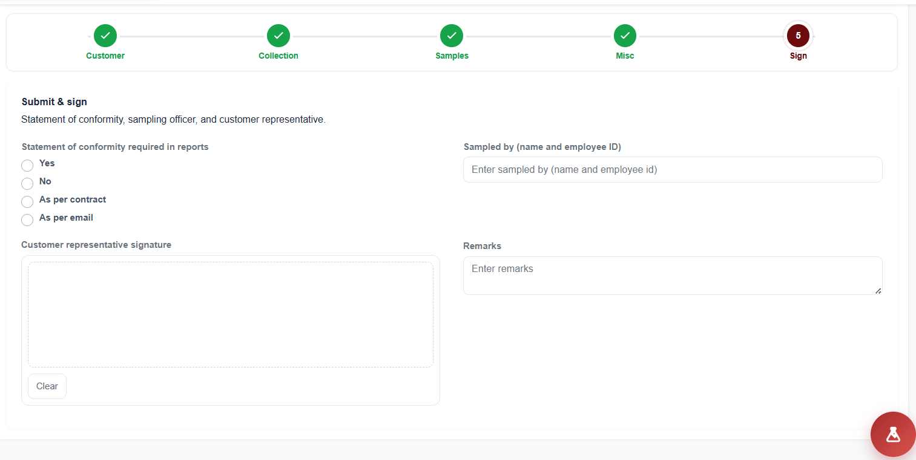

2- Test Request – Form for Food and Feed
- Customer – ok, the same that we have now.

- Collection – keep only:
  - Sampling date
  - Sampling location;
  - Transport condition
Other information we don´t need.
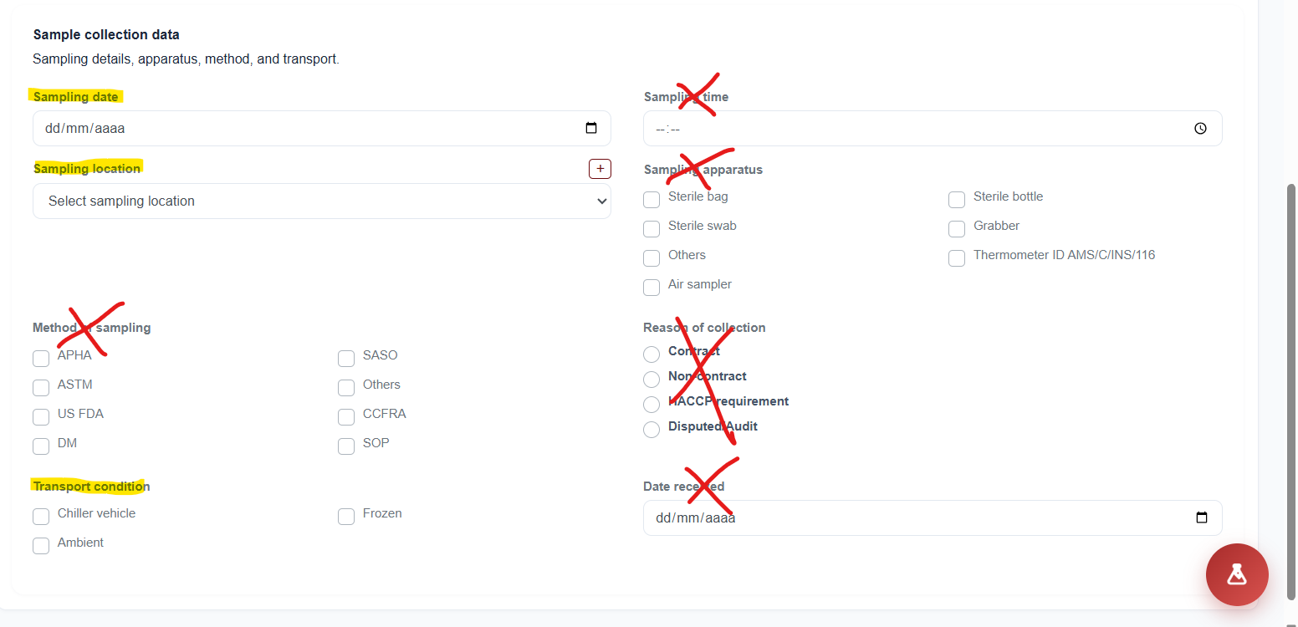

- Sample- we keep all fields, Add:
  - One field for samples (this field the customers are free for writing the sample)

- Misc – we don´t need this information:
  - Ship / vessel
  - Port of loading
  - Port of discharge
  - Seal
We can delete

- Sign -ok

